“ALL THINGS ELLINGTON”
ANNUAL FUNDRAISER
BY
THE ELLINGTON WOMEN’S CLUB
Member of The General Federation of Women’s Clubs
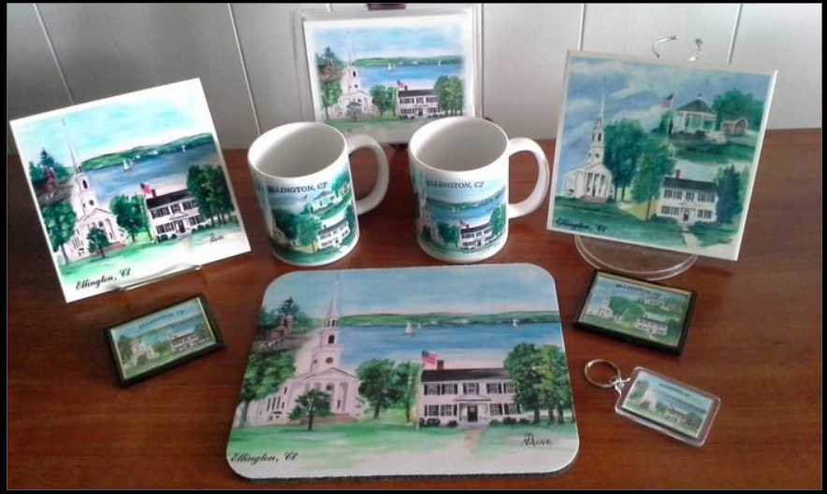
Artwork by Nancy E Paine, Simsbury, CT
All proceeds will contribute financially to many charitable and community organizations – including:
Ellington High School Scholarship Fund; Ellington Human Services; Ellington Senior Center; Tri-Town Fuel Bank; Tri-Town Shelter; Rocky Hill Veterans Hospital; Ellington High School Substance –Free Graduation Party and Hall Memorial Library

